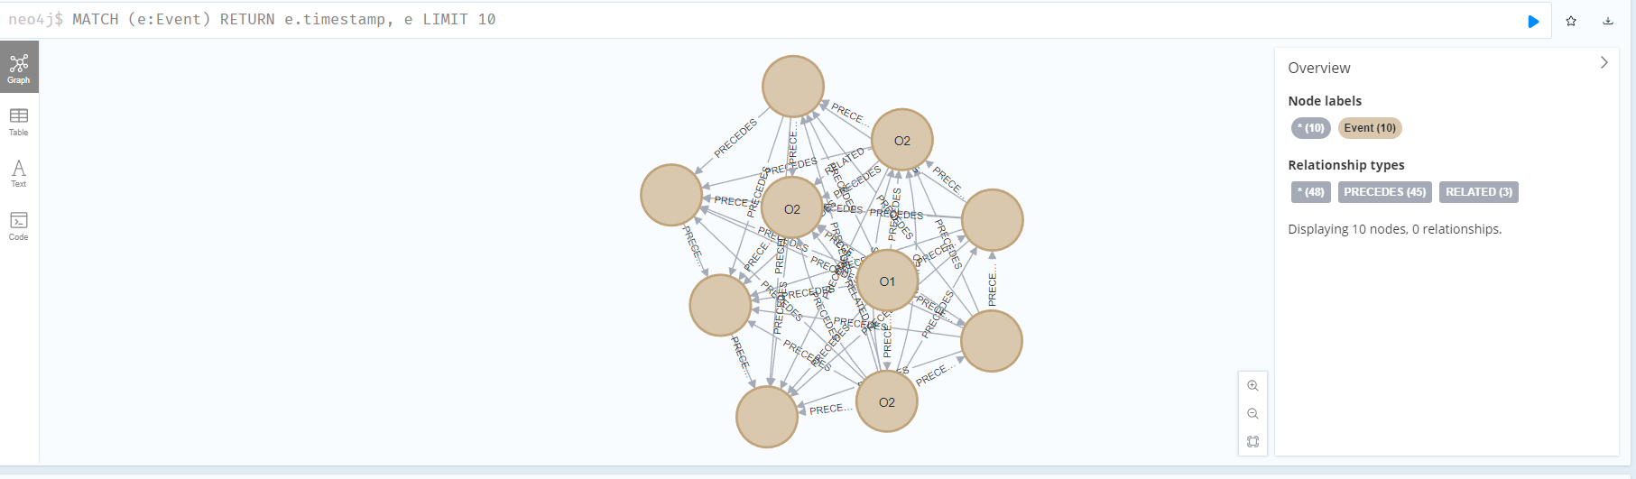

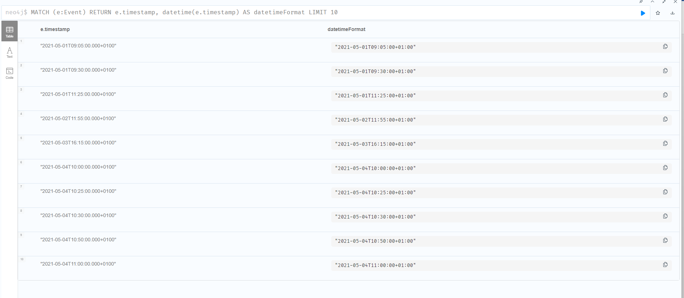

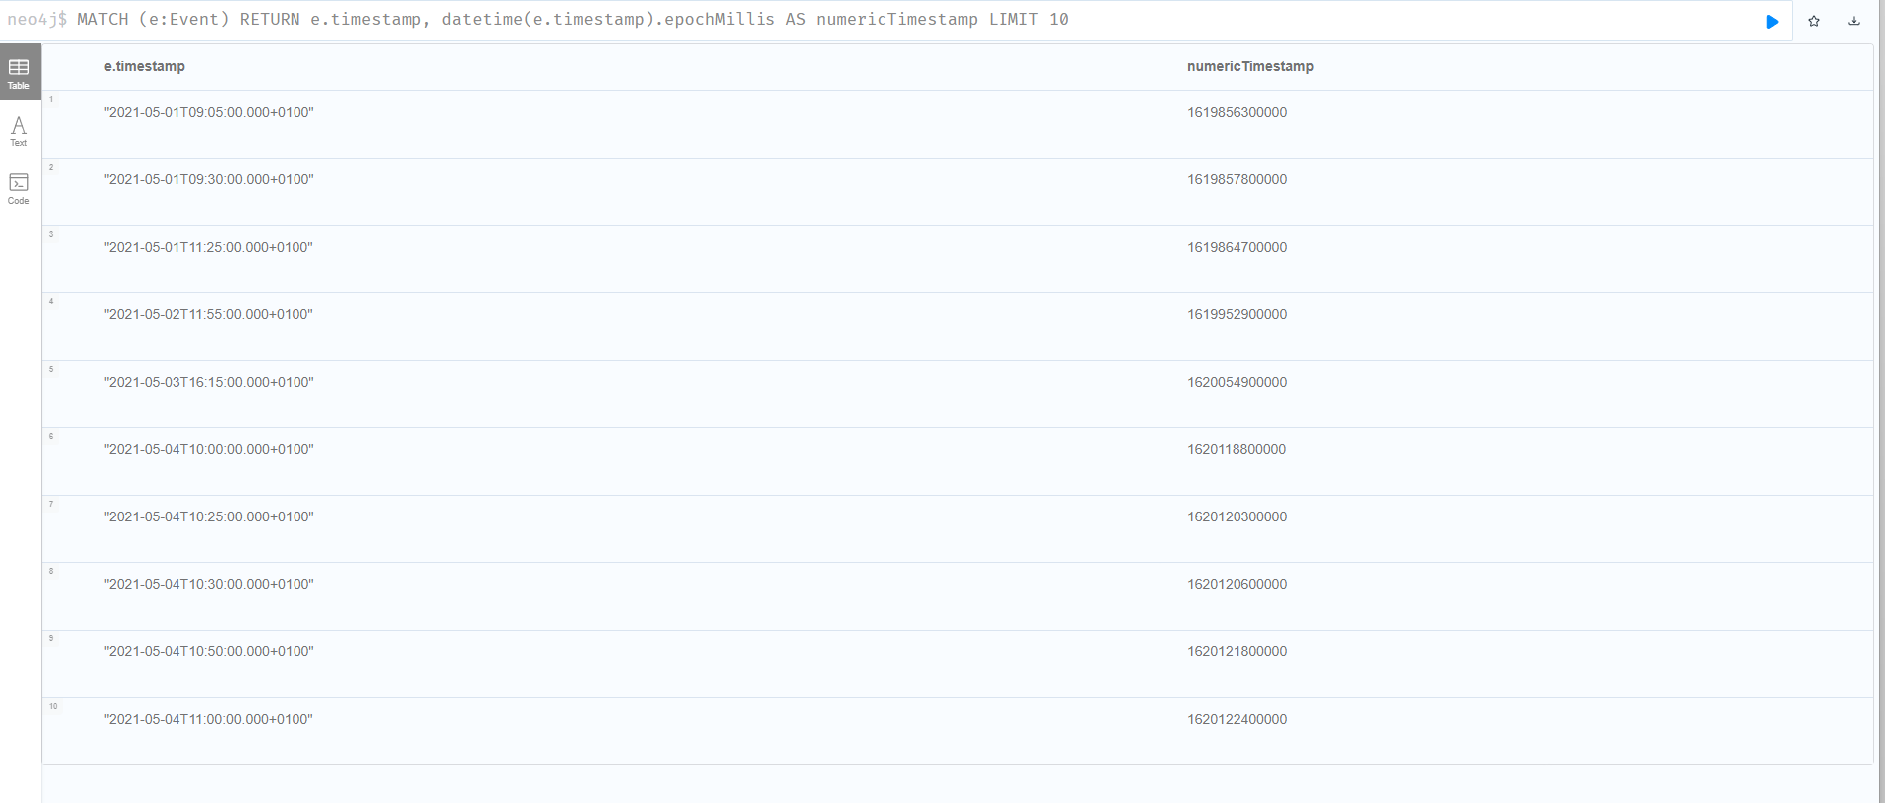

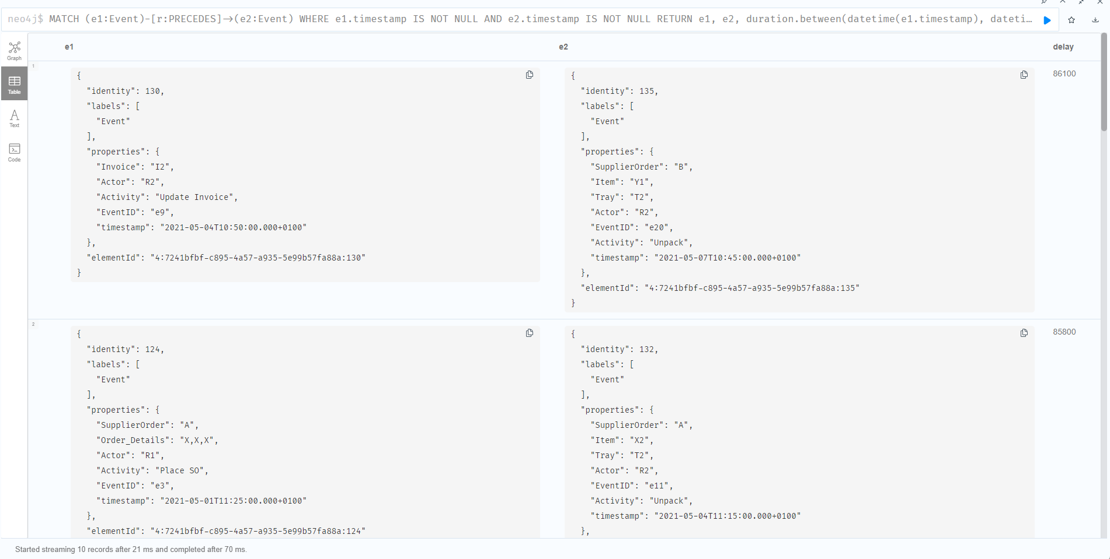

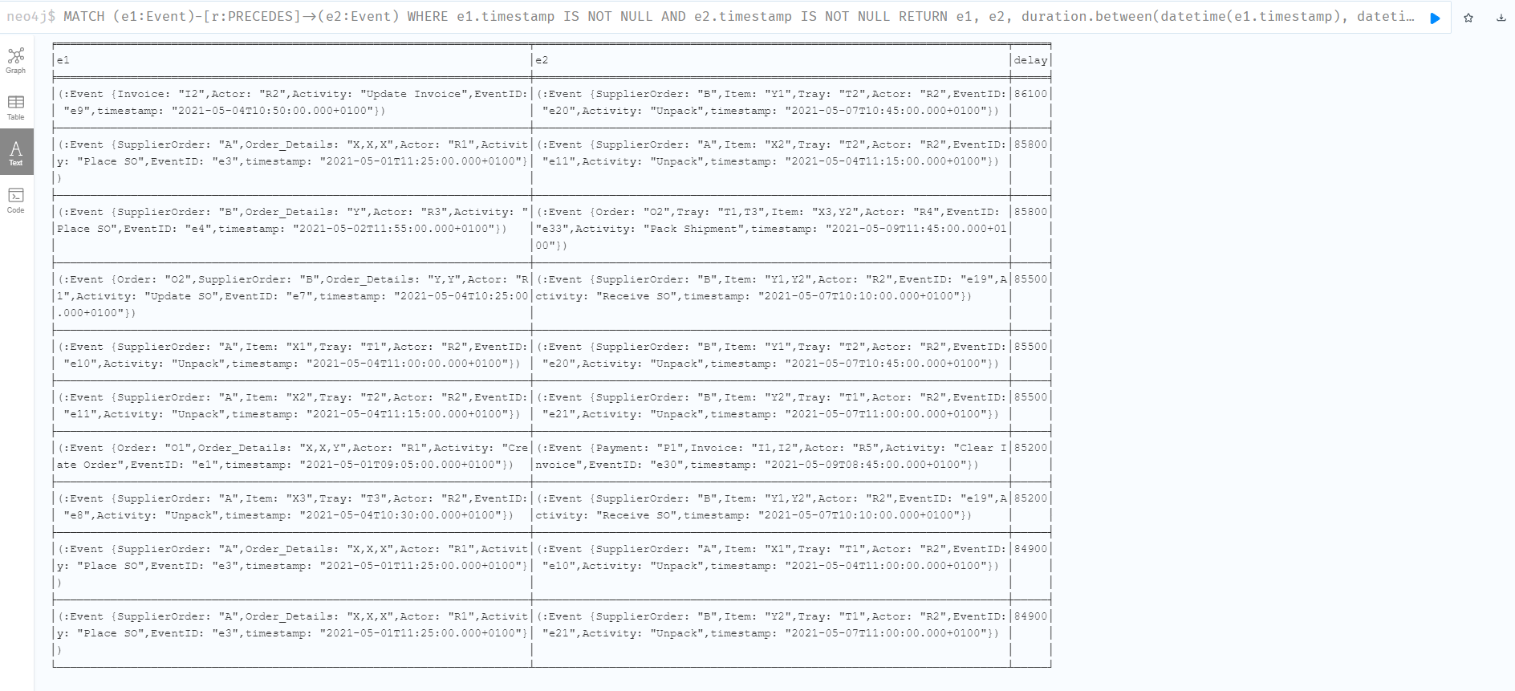

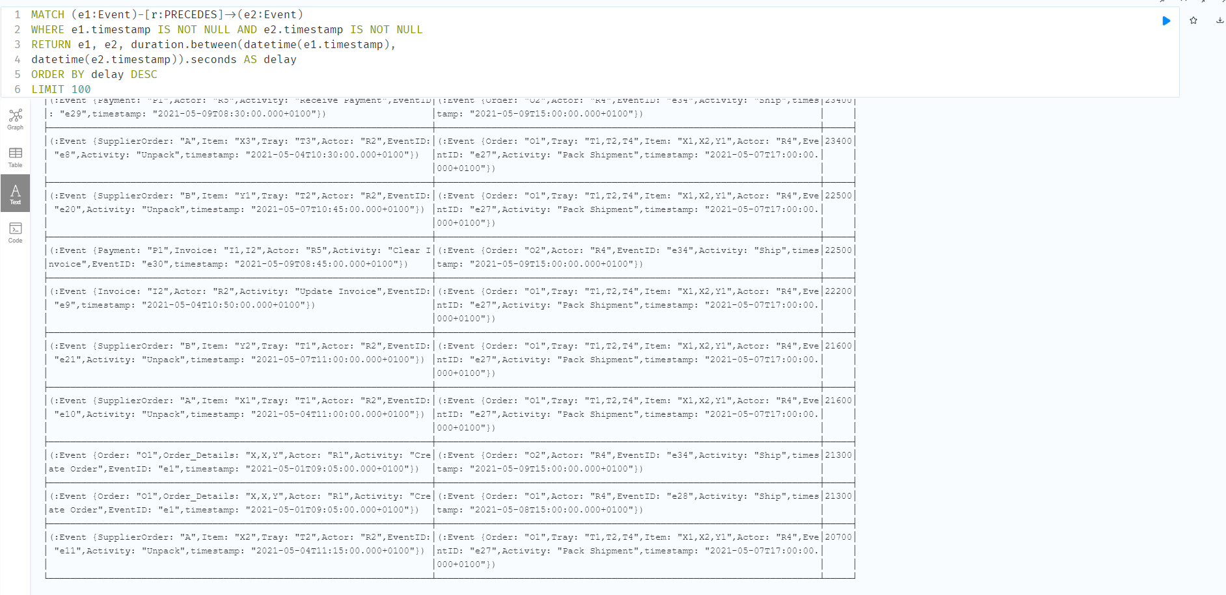

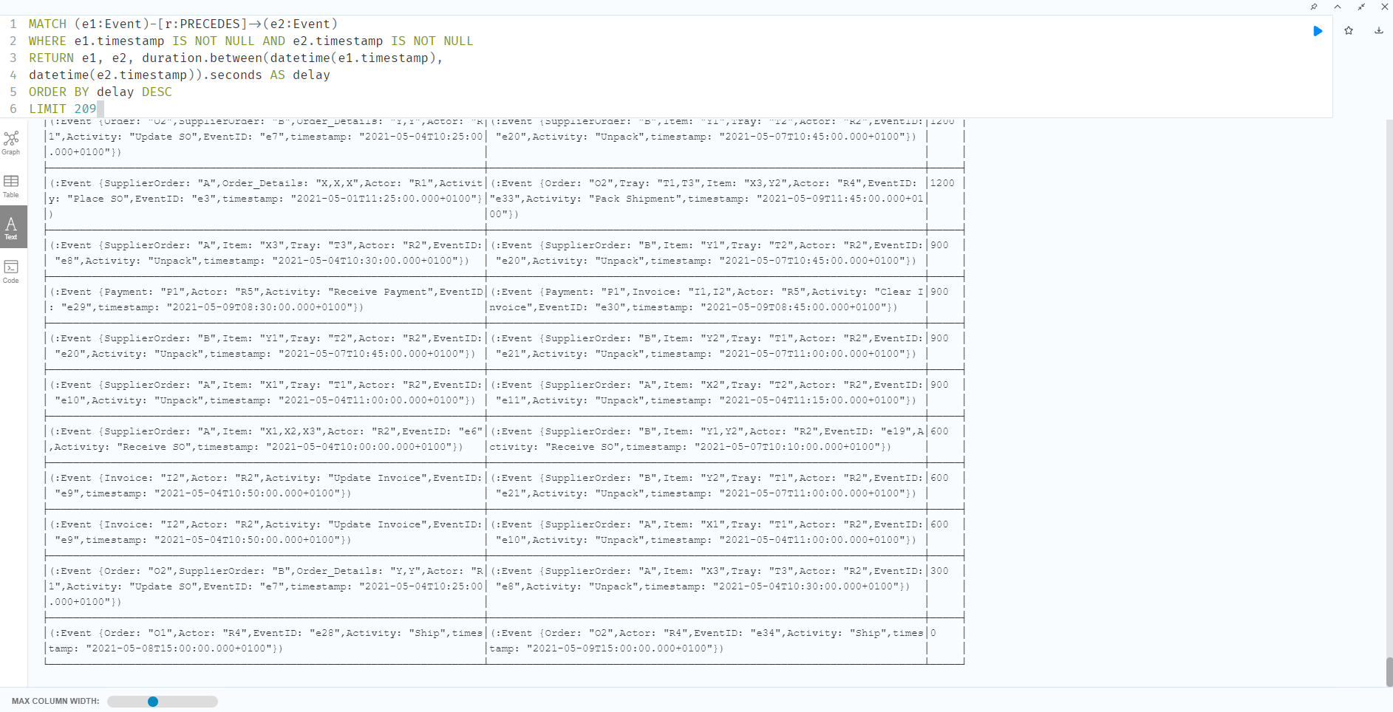

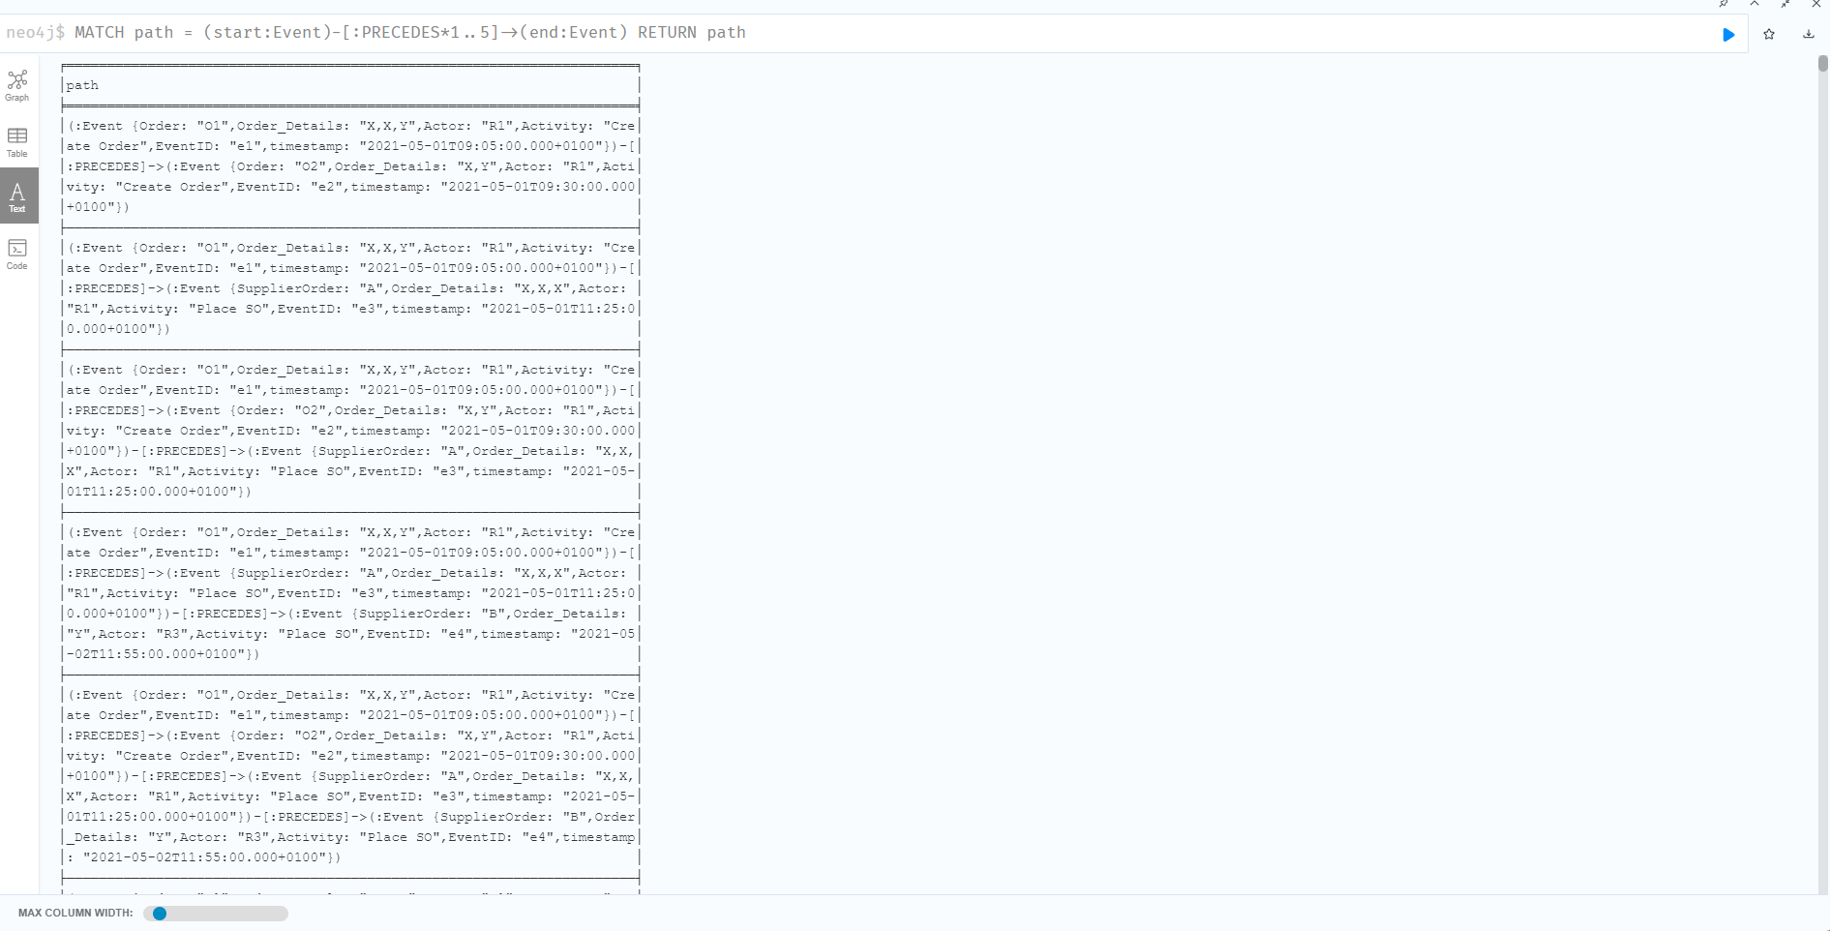

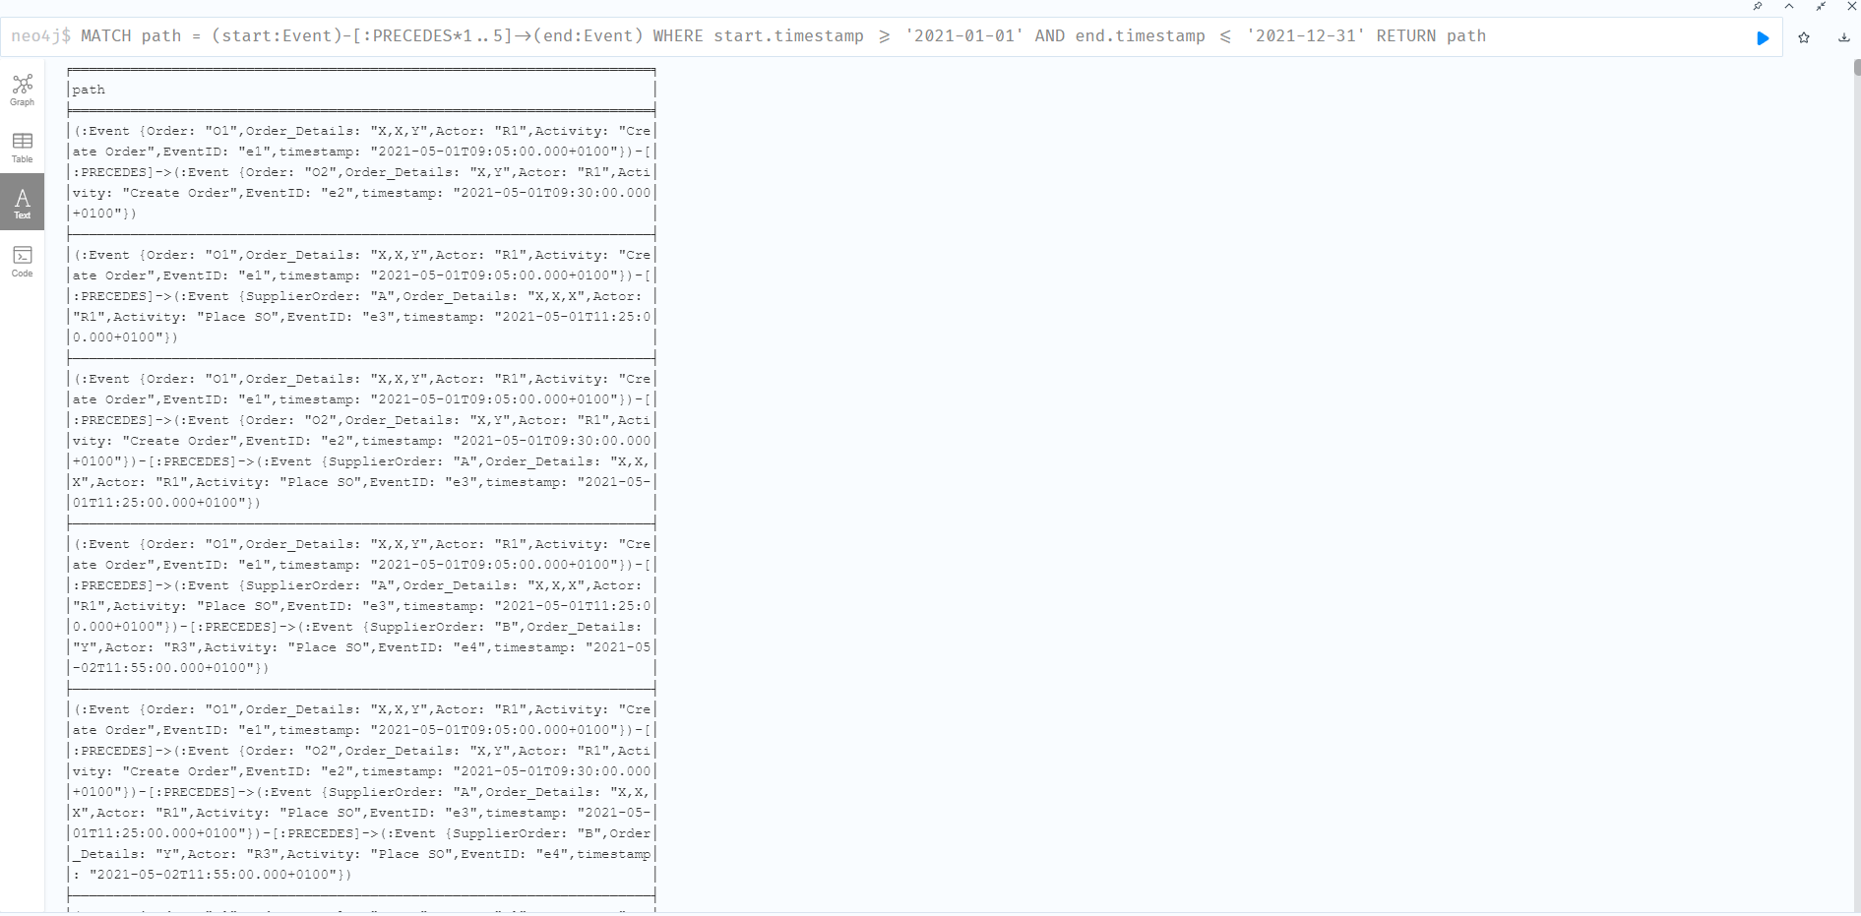

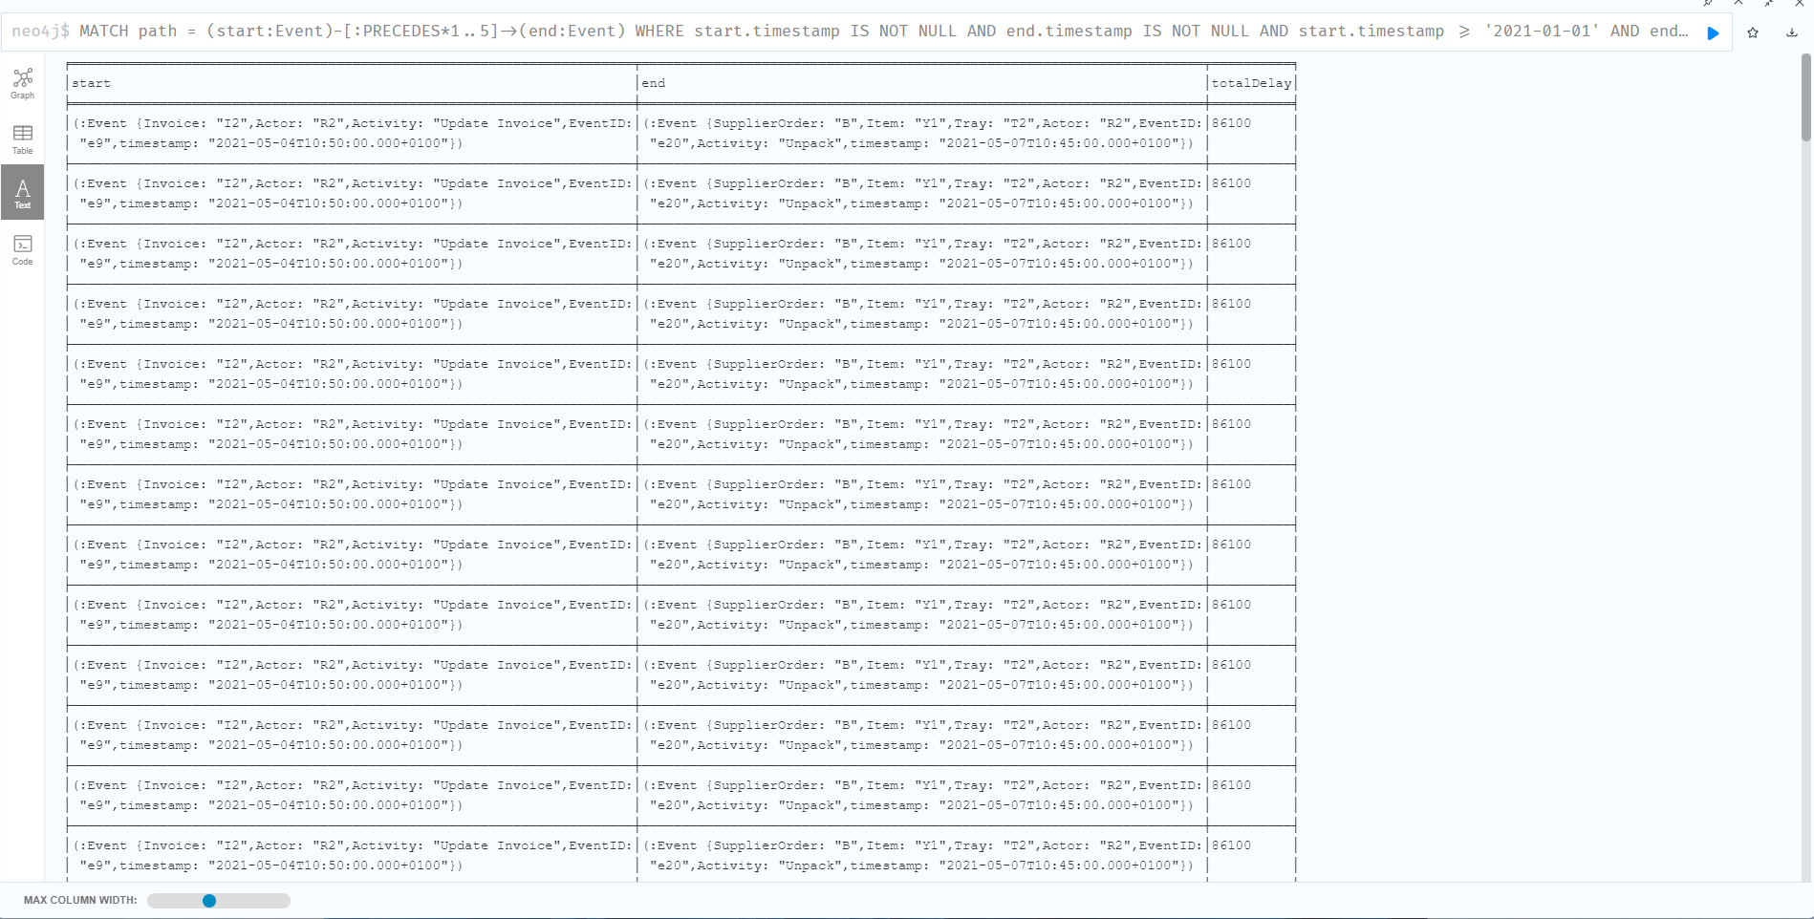

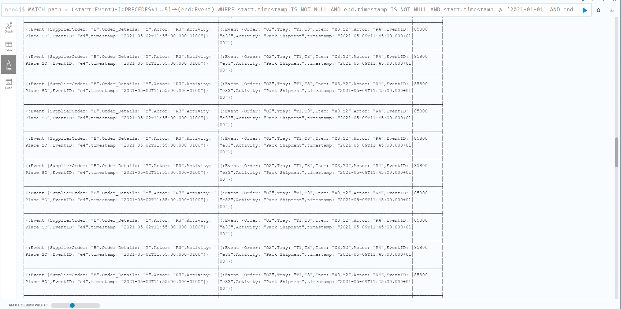

Cypher code:

MATCH (e:Event)

RETURN e.timestamp, e LIMIT 10

MATCH (e:Event)

RETURN e.timestamp, datetime(e.timestamp) AS datetimeFormat

LIMIT 10

MATCH (e:Event)

RETURN e.timestamp, datetime(e.timestamp).epochMillis AS numericTimestamp

LIMIT 10

MATCH (e1:Event)-[r:PRECEDES]->(e2:Event)

WHERE e1.timestamp IS NOT NULL AND e2.timestamp IS NOT NULL

RETURN e1, e2, duration.between(datetime(e1.timestamp),

datetime(e2.timestamp)).seconds AS delay

ORDER BY delay DESC

LIMIT 10

MATCH path = (start:Event)-[:PRECEDES\*1..5]->(end:Event)

RETURN path

MATCH path = (start:Event)-[:PRECEDES\*1..5]->(end:Event)

WHERE start.timestamp >= '2021-01-01' AND end.timestamp <= '2021-12-31'

RETURN path

MATCH path = (start:Event)-[:PRECEDES\*1..5]->(end:Event)

WHERE start.timestamp IS NOT NULL AND end.timestamp IS NOT NULL

  AND start.timestamp >= '2021-01-01' AND end.timestamp <= '2021-12-31'

WITH start, end, relationships(path) AS rels

WITH start, end, rels,

     duration.between(datetime(start.timestamp), datetime(end.timestamp)).seconds AS totalDelay

RETURN start, end, totalDelay

ORDER BY totalDelay DESC

LIMIT 100